TECHNICAL REPORT

New Horizons

Frank Blubaug, Alison Dunlop, Joseph Hu, Jian Ruan

2015

Contents

Task Description- Alison Dunlop 1

Project Scope 1

Defining the Scope 1

Original Scope from Wabash National 2

Clarification of Wabash National Specifications and Desires for Design 3

Reasoning Behind the Narrowing of the Scope 4

Assessment of Global Viability at Current Stage 4

Assessment of Wabash National Needs 5

Prior Art Takeaways from a Marketing Standpoint 5

Assessment of User Needs 5

Prior Art Takeaways towards User’s Needs 6

Prior Art Failures 6

Prior Art Successes 7

Project Scope Conclusions 7

References: 9

User Requirements- Frank Blubaugh 10

Introduction and RFP Proposal 10

Original RFP 10

Producers 10

Company History & Need for Diversification 10

Need for low investment cost 11

Users 11

Purchaser 12

Summary: 13

References: 14

Preferred Concept- Joseph Hu 15

Overview 15

Features & Design Properties 15

Assembly 15

Alternate Concepts 19

Final Design 21

Development of Concept- Jian Ruan 22

Foundation 22

Suspension 22

Framework 23

Deck 25

Shelter Enclosure 26

Assembly Process 28

Interior 37

Cost Estimation 44

Future Design Improvement 44

Plumbing 44

Electrical Utilities 45

Shipping 45

# Task Description- Alison Dunlop

## Project Outline

Our team, New Horizons, focused our work on providing an affordable and marketable mobile emergency shelter for the US market.This shelter is intended to house a four person family and is designed to be easily assembled by two people without the need for power tools or heavy equipment. Our shelter providesfamilies with a safe, weatherproof, and comfortable place to live while they rebuild their homes and their lives.

## Defining the Scope

By determining our project scope, we are definingthe contextin which our shelter is intended to be used. Our shelter is not intended for deploymentimmediately after disaster strikes. In the immediate aftermath of a disaster, most families and individuals seek out public relief centers for aid. However, these centers may only provide shelter and supplies for a week max. The mobile shelter is designed to fulfill the role ofinterim housing for displaced families from anywhere from six to twelve months until their homes can be rebuilt. Safety is a key factor in our design.The structure must be both structurally sound, so that it doesn’t fall apart during its use, and provide a sense of comfort and security for families living in it. Additionally the shelter must be easy to clean and sanitize, as well as weather insulated and provide a healthy living environment.

Perhaps the most important function of a shelter is to provide shelter from the elements. Weatherproofing our sheltermeans protecting the occupants from rain, snow, wind and heat. This means creating a shelter that has proper insulation and sealant, as well as an HVAC system for climate control.

Creating a marketable product the ultimate project goal. This means a strong competitive productthat is both innovative and practical in application. The design of our shelter must be relatively cheap to manufacture while not compromising on features and maintaining the standard of quality expected from the Wabash National brand.

The on-site assembly time frame we have decided to allow in the scope is for a maximum assembly time of less than half a day, with an assembly preference of within an hour or two. Note that keeping an on-site assembly time to around 15 minutes is not a part of our scope. The team’s focus is more on ease of assembly with the ability to do so without any prior training nor the use of power tools, than on assembly time.

## Original Scope from Wabash National

Wabash National Corporation’s goal is to expand its product portfolio while leveraging the company’s existing product, process and material capabilities. The original WN mobile emergency shelter is a “multi-purpose insulated solution for everything from mobile offices to temporary living quarters” that could be set up in about 15 minutes.

Wabash National presented our class with a request to redesign their mobile emergency shelter so that it could be implemented in a variety of geographical locations to provide emergency housing relief. A list of desired criteria for the shelter was given in their Request for Proposal (RFP) as shown below.

**RFP Minimum Criteria:A successful proposal must meet the following criteria**

* Establish WNC as an innovative leader in emergency shelter product offerings, through the proposal’s unique features and capabilities, durability, style, eco-friendly/elements of sustainable design, and user centric attributes.
* Leverage the scale of developed product/process/raw material capabilities of Wabash National Corporation.
* Differentiate against competition as best total value over the life of product (including cost of manufacture, transport, installation, ownership, operation, maintenance, and residual value)
* Ability to customize to different applications in targeted geographies
* Ease of on-site assembly that requires minimum time, tools, equipment and manpower
* Not exceed current on-site construction times.
* Demonstrate feasible manufacturing and customer transport, giving full consideration to current standard cost metrics prevalent in the industry.
* Utilization of standard tools for assembly
* Ability to work with existing delivery systems
* Limit size offerings to current industry container “standards”; U.S. baseline is 16’ x8’x 8’.
* Initial manufacturing location Wabash National facilities in NE Indiana
* Product Delivery Target Geographies: North America S.E and Midwest; Latin America; Asia Pacific; Middle East

### Clarification of Wabash National Specifications and Desires for Design

After sharing ideas and talking to representatives from Wabash National, some project clarifications were brought to light on what could be included and excluded from the list of design requirements, as well as the priorities and focal points of the design.

It was stated in the Wabash Nation product listing that the mobile shelter had an onsite assembly time of around 15 minutes, but it was not mentioned that this time was based off of an assembly of the shelter using a forklift. It was also clarified that the use ofDuraPlate, while encouraged, is not a requirement.

Due to the multi-function design of the original WN mobile shelter, there was no specific target market to market to. Wabash National had conducted a potential user survey asking prospective buyers what they considered to be priorities of a mobile office and mobile shelter should be. The responses ranked the perceived importance of design factors on a scale of 1 (top priority) to 5 (lowest priority).

Table 1: Wabash Nation customer survey buying criteria

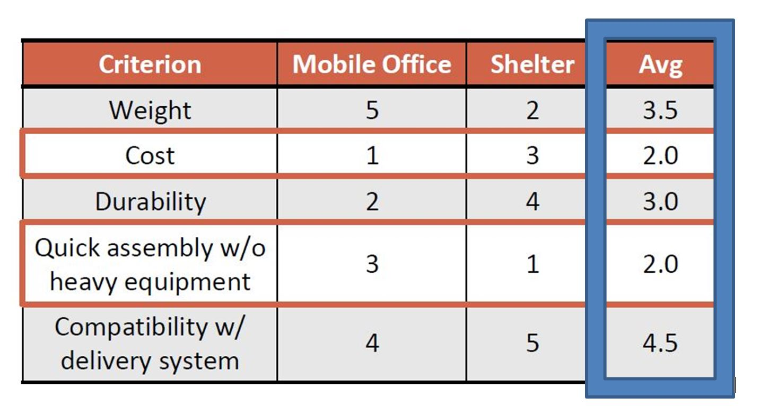

As shown in the above table, responses for the mobile office design and the shelter design vary drastically in their perceived design criteria. By attempting to compromise and meet the criteria for both demographics, the shelter sacrificed the ability to satisfy either market.

Investigative research showed that a higher need and a larger market could come from the mobile emergency shelter rather than the mobile office. In 2012 the amount of money spent on temporary housing in the aftermath of Hurricane Sandyhas been estimated at roughly $25.2 million dollars for a three month period (Appendix). Displaced families do not always have the ability to repair or replace their home. Although the estimates vary from year to year, an estimated of $4 billion worth of damage is caused by natural disasters per year.

## Reasoning Behind the Narrowing of the Scope

### Assessment of Global Viability at Current Stage

### Each team member researched the viability of implementing a mobile emergency shelter in the geographical locations listed in Wabash National’s RFP. It quickly became apparent that international deployment posed an incredibly high number of challenges including but not limited to: international shipping regulations, local infrastructure, increased cost, climate consideration, and various political & cultural issues. It was decided that due to the lack of current sales in North America, and the challenges posed by international deployment, to focus our target market on the United States.

## Assessment of Wabash National Needs

### Prior Art

There are three classification of post disaster housing: sheltering housing for immediate relief directly after a disaster occurs, interim housing for longer usage while the victims get their permanent homes rebuilt, and permanent long term housing. Sheltering housing units are fairly low cost (≈ $1,000). These units featuring quick set up, low maintenance, easy transportation, and are only meant to be used for short periods of time. Interim housing have a larger range of costs ($2,000-$20,000).The setup time is also much broader depending on how it was shipped. Common features found in existing shelters include collapsibility while in transport, lightweight and easy set up (assembly times ranging from 10 minutes to an hour), and low cost.

Compared to the average sheltering housing units on the market, the weight, cost, and feature set of the current Wabash National mobile shelter are not competitive against other products. When compared against dedicated housing units, the current price point of the Wabash National shelter is above the average price of competing products. Comparatively, when judged against mobile office units, the Wabash National shelter lacks the competition’s robust features. Based off this information and the analysis of the user’s needs led our group to the conclusion that the shelter should instead focus designing a product catering to one target market, specifically interim housing shelters.

### Assessment of User Needs

Table 2: Focus on designing an emergency shelter

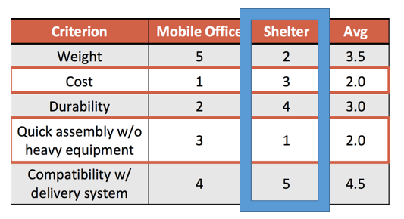

Research into prior art’s successes and failures helped our team shape the priorities of our design. The top priority became designing a shelter that was easy to assemble without the aid of heavy equipment. Our next priority, was reducing the overall weight of the shelter. Although cost was prioritized as a greater desire than durability, our team decided that durability included safety, which couldn’t be sacrificed in order to reduce cost. Our team need to reconcile those two aspects in order to find a happy medium that did not compromise on the first two priorities. As stated earlier, one of the constraint of the RFP was to maintain the standard of quality associated with the Wabash National brand. Only after the minimum safety factor is met, does cost take priority.

## Prior Art Takeaways towards User’s Needs

### Prior Art Failures

In most disaster scenarios one of the biggest obstacles to relief deployment is accessibility and skill to tools and equipment. Our shelter design needs to be able to be assembled by individuals with little or no help, as there may not be an adequate number of experts available to assist these people. One of the major aspects of the original shelter our team wanted to improve upon the requirement of a forklift to install the walls and roof of the shelter.

Another issue that has come up in prior art was the failure of the shelter to provide a healthy living environment. The most notable example of this are the FEMA trailers provided to the displaced residents of New Orleans following Hurricane Katrina. The trailers were made with an insulation that reacted poorly with the region’s climate. The heat broke bonds that held toxic chemical compounds in a polymer lattice. Once the bonds broke, the toxic chemical compound was released in the form of a gas, filling the shelter and causing many people to fall ill. Our team took note of this failure and devoted time into researching the materials, its toxicity, and ability to withstand heat. This example raised the aspect of the user health and wellbeing as part of our project scope.

### 

### Prior Art Successes

The United Nations created SPHERE Project standards for refugee housing that cover international guidelines regarding living standards in temporary housing shelters. SPHERE takes a holistic approach to housing design including considerations to the physical, social, cultural, and emotional needs of people. Within the SPHERE Project handbook, there are a specified range of activities and requirements a successful shelter should follow including:

* + **Livability- How well the shelter accommodates for the residents’ daily needs**
  + **Build Time- Speed at which structures can be built and lived in**
  + **Range of Use- Environmental, geographical, cultural, and governmental adaptability**
  + **Cost- Cost effectiveness of the unit absolutely**
  + **Environmental Footprint- capable of HUD certification**
  + **Production Lead Time- Have an immediate number of housing units ready to ship at the time of need.**

## 

## Project Scope Conclusions

New Horizon’s final project scope differs from Wabash National in a several ways. A few aspects stay within their scope margin, such as creating a shelter that has on-site assembly capabilities, utilization of standard hand tools, and the ability to be deployed via existing delivery systems.Other ideas are outside of Wabash National’s original scope due prioritization of the stakeholder’s needs.

Overall our shelter is designed to meet the scope of an affordable four person family interim housing unit that can be assembled by two people using basic hand tools while still providing a safe, secure and healthy living environment.

## Citations

* *National Disaster Housing Strategy*. (2009). Washington, DC: FEMA.<http://www.fema.gov/media-library-data/20130726-1747-25045-2030/ndhsannex2.pdf>
* Shelter: The RDM - Visible-Good.com. (n.d.). Retrieved March 13, 2015, from http://visible-good.com/shelters/
* FORTS® Offers Luxurious Portable Buildings & Spacious Fold-Out Modular Buildings for Rent. (n.d.). Retrieved March 13, 2015, from http://fortsrental.com/
* Statistica. “Average Size of a Family in the US 1960-2013.” The Statistics Portal. 25 Feb. 2015 Web.
* “Family Household Stats 2013.” *Table F1: All Races*. United States Census Bureau.  11 June 2014.  Web. 8 March 2015.<http://reliefweb.int/sites/reliefweb.int/files/resources/Full_Report_2950.pdf>
* "Humanitarian Charter and Minimum Standards in Humanitarian Response." *The Sphere Project*. The Sphere Project, n.d. Web. 10 Mar. 2015.

# User Requirements- Frank Blubaugh

## Introduction and RFP Proposal

Wabash National proposed this project to the IDE 485 class in January of 2015. They asked us to update the design of their portable emergency shelter. Through a review of Wabash National's business needs and a target market, we propose to update and refocus the emergency shelter to focus on specifically the needs of those profoundly affected by disaster.

## Original RFP

The criteria provided to the IDE485 class by Wabash National are listed in the original RFP document in the appendix. The focus of the RFP is to establish WNC as a leader in the in the market while showing that the cost of ownership of the shelter is superior to other products on the market. The restraints of the RFP include keeping the shelter standardized in terms of manufacturing capabilities and shipping. Wabash National did not provide much further guidance in terms of where they wanted this project to go as long as we kept any possible solutions that we may create remain within the scope and capabilities of Wabash National’s current manufacturing facilities. With this flexibility, we propose that the shelter should alter its focus from a hybrid market of the first generation of the shelter to focusing entirely on the disaster relief market. We believe that this approach holds the most potential for an easily implemented solution that does not involve a great amount of engineering or manufacturing investment by Wabash National while still enabling them to capture the significant amount of the dollars spent on disaster relief housing.

## Producers

Wabash National has long been a leader in the overland shipping industry and is the leading producer of dry cargo freight vans. Furthermore, they are a top producer of liquid transport as well (n.d.).In an attempt to leverage current products for a new market, Wabash National has sought to diversify some of its product line at as low of a cost as possible to the company. The department within Wabash National responsible for this corporate goal is the Diversified Products Division. One of the products they have been developing for the last several years has been a portable shelter intended for use in both commercial and emergency settings.

### Company History & Need for Diversification

Wabash national was founded in 1985 to begin the production of freight van trailers for the trucking industry in the United States. Headquartered and located in Lafayette, Indiana, it is the number one producer of dry truck vans it the United States. In 2008, the financial crash precipitated on the collapse of the sub-prime mortgage market, very nearly caused the closure of the company. During the reconstruction process, the company concluded it was too focused on a singular market and has since then sought to diversify its product line to insulate itself from future market variations. One such proposed idea is the construction and sale of temporary shelters that FEMA can use to replace their current method of disaster housing. Disasters are an unpredictable force of nature, and while the shelters could not be relied upon as a steady revenue stream, the occasional jolt of business could be enough to sustain the company during dips in the business cycle (n.d.).

### Need for low investment cost

This shelter could become an important part of the Wabash National portfolio, but it will never become a major part of a company with $1.8 billion in sales in 2014 (n.d.). In an ideal world, this product would not even be needed, but as recent history informs us through the events of Katrina and Sandy, an emergency shelter is indeed something that must exist. Due to the irregularity of the product's demand and the small amount of revenue that the product would bring in, the startup costs for this shelter cannot be large. A good design will be a shelter that will capitalize on the current capabilities of Wabash National at a minimal execution cost to supplement the product portfolio of the company.

Through this analysis we conclude that Wabash National needs a easy to produce emergency shelter that allows it to quickly produce a shelter within its current manufacturing capabilities to produce a shelter on demand for an emergency should it occur.

## Users

The primary users of these shelters are those who have been affected by disaster or other loss of home tragedy. The scope of the disaster provides the largest challenge to this situation. In many situations, there are a large number of lives altered by the disaster. However, the problems faced by most people are more temporary. Homes that need relatively minor repairs greatly outnumber the number of homes that must be totally replaced. A simple illustration of this is to look at the FEMA emergency housing spending after Hurricane Sandy in 2012. While many people initially had to seek shelter after the storm, the vast majority of those people were back in their original homes within one week of the disaster. During that time, the major repairs could be made, or a temporary solution could have been reached, that would allow the residence to become livable again. (Anderson, n.d.). However, three months after the disaster, there were still 3,500 families living in temporary housing solutions after Hurricane Sandy. Most of these people were living in some sort of rental housing, usually a hotel (Perry, 2013).The cost for housing these people has been estimated at roughly $25.2 million dollars for that three month time frame. Temporary home replacement does not always serve the largest population, but it is still a sizeable market with needs that are not being met easily by the market.

The annual amount of damage to homes from natural disasters can vary widely from year to year. In a typical year, the estimated annual housing damage caused by natural disasters excluding hurricane damage is $4 billion (Kelly, n.d.). Fires typically cause an additional $7 billion in damages every year nationally (*Fires in the U.S.*, 2014). The effects of hurricanes can widely vary from year to year. In a year with a large storm, the damage can be catastrophic with Katrina and Sandy combining to do nearly $200 billion in a seven year time span. Other disasters take nearly 20 years to match the damage two catastrophic storms can contribute on their own. Unfortunately, there is not readily available data regarding the number of homes that are completely destroyed by these events as opposed to the total cost of damage caused by these storms.

Rebuilding after losing a home is a taxing and intensive process. The displaced people must deal with emergency relief agents, secure housing, coordinate the construction of a new home, interact with insurance claims all while juggling everyday needs without a place to live. A shelter must be able to provide the basic needs of the family unit while they conduct the repairs they need on their home or build a new home. A typical home construction in an ideal situation takes 8-9 months to complete, and to account for the cleanup and the demand of services after a disaster, we anticipate that many users will need a 12 month family habitat (Siniavskaia, 2013). The US census has found that the average family size is roughly 3.4 people and we round that number up to 4 for the minimum shelter size for our design.

The amount of assistance after a disaster is heavily dependent on the location and scale of the disaster. Regardless, the more resources that can be conserved during the reconstruction process, the faster the reconstruction can be completed. Heavy Equipment such as forklifts are usually in high demand or can be difficult to get into a disaster situation if the infrastructure is destroyed. The shelter therefore needs to be able to be assembled by hands by the people who will be living in the shelter. In order to meet this need, we propose that the maximum component lift weight is 100lbs based on the OSHA safe lifting guidelines for an individual (OSHA, n.d.). Furthermore, our design will need to be simple enough to understand the assembly process that people with no technical training and limited literary skill will be able to assemble our shelter.

## Purchaser

It is unlikely that the direct user of this shelter will be purchasing the shelter himself. It is more likely that an emergency relief service would be providing these shelters to those affected. The role of the distributor or purchaser of this shelter could take many forms: local and state disaster relief agencies, insurance agencies filing claims, international charities, and the Federal Emergency Management Agency (FEMA).

Local and state groups have large amounts of variation in their documentation, requirements, budgets, and points of contact that make analysis difficult. Private organizations such as the Red Cross typically do not publish their internal review documentation so it can be difficult to predict what their strategic planning. FEMA on the other hand has published many reports for public or congressional consumption detailing internal reviews and strategy for future disasters.. Additionally, FEMA will be put in the most situations to implement a shelter design due to their nationally focused mission. FEMA’s ubiquity in the market, ease of availability of material, and leadership position in the disaster relief agencies in the United States makes it a prime candidate for purchasing the shelter.

As per FEMA's own disaster relief plan, the main intent of disaster relief housing is to get most people into some sort of permanent structure as soon as possible. FEMA classifies the recovery housing period into three different structures time spans: sheltering, interim housing, and permanent residence. Sheltering is the time immediately after or during the disaster when people may be separated or the homes may not yet be safe to return to as the disaster situation is still on-going such as flooding. These situations are usually addressed by placing people into large semi-public or public locations such as sports arenas, places of worship, or public schools. The ideal plan for this time frame is to get people moved into a different housing solution within 96 hours after the disaster begins. This can be extended to up to a week, but after that time FEMA emphasizes the need to get people out of these communal situations (FEMA, 2009).

FEMA does not see itself as the provider of the sheltering stage of disaster relief housing. Instead, FEMA believes its primary role is in the recovery and rebuilding stage of a disaster. Their ability to leverage the spending power and jurisdiction of the United States Government makes them more suited to helping people recover by quickly moving large amounts of resources and money to the affected area. According to FEMA documentation, it is preferable to move an affected family directly into permanent housing from a shelter. When this is not possible, FEMA exercises a number of options to get the displaced families into some sort of housing. FEMA prefers to use local rental housing units and hotels due to their availability and economic stimulus to the area, however these can be a costly solution and there is not always the capacity to support the needs of the population. In these cases is when FEMA purchases some sort of housing trailer. A typical trailer FEMA purchases for this use costs $30-$40 thousand dollars each, and they are typically not recovered at the end of their use. FEMA has furthermore acknowledged the inadequacy of this strategy but has yet to adopt a different one (FEMA 2009).

A disaster can occur in any part of the country at any time, and FEMA’s national mission mandates that it needs to be prepared for both a hurricane in Florida and an avalanche in Montana. The large variety of climate patterns that exist in the US, the variability of weather throughout the year, and the length of the rebuilding time means that FEMA needs a shelter that can work in all of these environments simultaneously so that only one solution is for FEMA’s use.

When a major disaster strikes, FEMA quickly will spend a large sum of money to house those. During especially catastrophic incidents such as during hurricane Katrina or Sandy, the number of people who need assistance reaches into the tens of thousands of individuals. FEMA openly admits they do not have a good solution to this problem and is actively seeking a solution to reduce the cost of sheltering this population. With a current per unit cost of $30-$40 thousand dollars per unit, a well-priced emergency shelter could be appropriate positioned in the market to quickly capture a large amount of the dollars spent on housing disaster victims. A shelter provided by Wabash National would provide the company not only another revenue source, but also the chance to become civically engaged with the national community and demonstrate their technical capability in a humanitarian way.

### Summary

**The below is a list of our key design requirements:**

* **The shelter must utilize the current manufacturing capability for Wabash National**
* **The shelter must work in a variety of climates**
* **The shelter must have a maximum component weight of 100lbs**
* **The shelter must house a family of four**
* **The shelter should have a habitable life of 12 months.**
* **The shelter must be more affordable than current solutions.**

## References:

Anderson, L. (n.d.). Housing Options for Hurricane Sandy Survivors [FEMA]. Retrieved from https://www.fema.gov/blog/2012-11-10/housing-options-hurricane-sandy-survivors

FEMA. (2009). *National Disaster Housing Strategy*. Retrieved from http://www.fema.gov/pdf/emergency/disasterhousing/NDHS-core.pdf

*Fires in the U.S.* (2014). National Fire Protection Association. Retrieved from http://www.nfpa.org/research/reports-and-statistics/fires-by-property-type/residential

Gus. (n.d.). *Presentation to IDE485 Class*.

Kelly, J. (n.d.). *Unless Modified, FEMA’s Temporary Housing Plans Will Increase Costs by an Estimated $76 million annually* (No. OIG-13-102). Department of Homeland Security: Office of Inspector General. Retrieved from http://cnsnews.com/sites/default/files/documents/FEMA%20IG%20report.pdf

OSHA. (n.d.). Materials Handling: Heavy Lifting [OSHA]. Retrieved from https://www.osha.gov/SLTC/etools/electricalcontractors/materials/heavy.html

Perry, W. (2013, April 28). After Hurricane Sandy, Homeless still number in Thousands in New York, New Jersey. *Huffington Post*. Retrieved from http://www.huffingtonpost.com/2013/04/28/hurricane-sandy-homeless-homelessness_n_3174444.html

Siniavskaia, N. (2013). *How Long Does it Take to Build a House*. NAHBA Eye on Housing. Retrieved from <http://eyeonhousing.org/2013/10/how-long-does-it-take-to-build-a-house/>

# Preferred Concept- Joseph Hu

## Overview

The final design of our mobile shelter is based on improving three components from the original Wabash National mobile shelter: the feasibility of assembly for untrained users, the potential target markets, and creating a product that is cheaper to manufacture but still contains all the features provided by the original device. Compared to the original Wabash National mobile shelter, the redesigned shelter provides a 25% increase in livable space, a 20% decrease in cost, and a 10% overall weight reduction from.

## Features & Design Properties

Our redesigned mobile shelter measures 16ft long, 8ft tall from the floor to the ceiling, and 10ft wide to provide a living space of 160ft2. The width was increased from the original 8ft in order to meet the Sphere Project standards of living space of 3.5m2 per person. A foundation was added to the shelter featuring mechanical jacks to adjust for uneven terrain.

The walls and roof of the shelter are designed to be assembled by untrained users without the need for heavy equipment or power tools. Each individual component of the shelter is designed so that it will not exceed lifting load of 50lbs per person. By removing the need for heavy equipment, the cost and logistics of deployment are greatly improved. The shelter weighs roughly 2135.36lbs, approximately a 10% reduction in weight from the original design.

Due to the focus on providing interim housing for families of four, our team felt it prudent to provide a basic amount of amenities to help sustain users for up to 12 months. The most important of these components were securely locking doors and windows in addition a locking safe to store valuables in. We want to provide a sense of safety and security for these families, to help alleviate the trauma and stress of losing a home. Additionally a dresser and locker are included to store clothing and other items. A small kitchenette space with a countertop, sink, and burners in provided so families can cook for themselves during the recovery period. The provided sink is a basin with a faucet and drain that lead to an external wall hookup where water can be taken in and drained out. The shelter is also equipped with a collapsible table and four beds and chairs that can be folded down to provide extra living space. These fixtures are designed to be mounted onto the same L-track attachment rails featured in the original Wabash National shelter.

The estimated cost for just the shelter is $3,231.39 while the cost of the amenities is $1,856. The total estimated cost of our design is $5,087 roughly a 20% decrease in cost from the original Wabash National design.

## Assembly

The assembly process of the original mobile shelter was the greatest limiting factor in the previous model. The original Wabash National shelter was designed to be collapsible during transportation. The walls and roof fold down to minimize volume during shipping. However, during the assembly of the shelter, the walls and roof are too heavy to be manually lifted and the aid of heavy equipment is required. This necessity greatly complicates the logistics of shipping and delivery of the. These issues were addressed in our design by breaking the floors, roof and walls into smaller components that would be assembled on-site. The redesigned assembly process eliminates the need for heavy equipment, while improving on safety and ergonomics of the assembly process.

The assembling the foundation is the first step in building the mobile shelter. It is comprised of six mechanical jacks, with a frame constructed of steel beams resting on top. There are four flat steel plates resting on top of this frame to provide support for the floor panels.

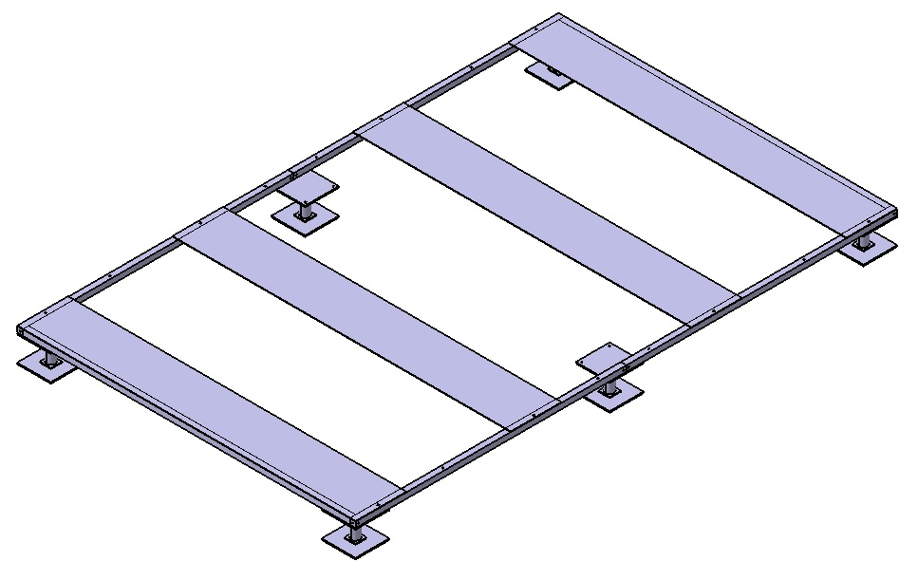

Figure 1: The foundation

The next phase of the assembly is laying down the floor panels onto the foundation. Next the user will attach wall posts which connect to lips on the end of the floor via pin joints. The tops of these posts will be connected via a trapezoidal roof bracket to form an arched support beam. This arch is rotated horizontally until it lays flat on the floor panels. The user will then attach the roof panels and then a second set of wall posts and roof brackets as shown below.

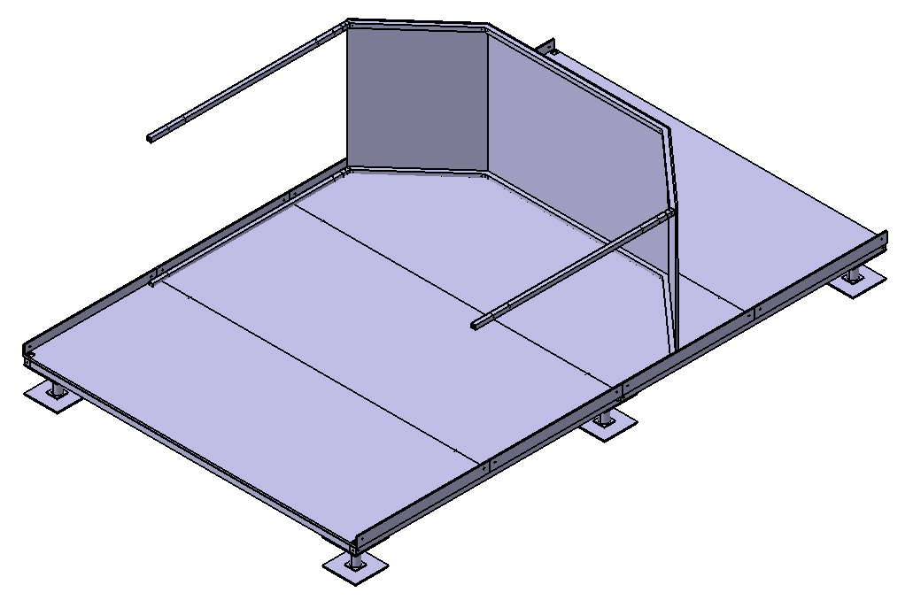

Figure 2: The arch beam with roof panels attached

The user then rotates the arch into an upright position and then secures it to the floor. Now the side wall panels can be mounted and secured onto the wall posts.

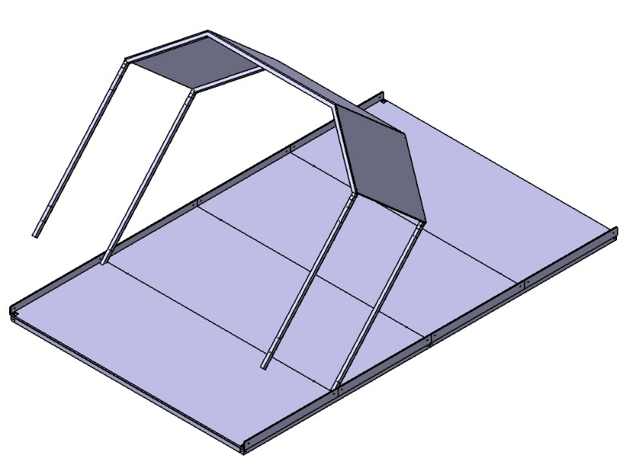

Figure 3: Rotate the arch and roof panels into an upright position

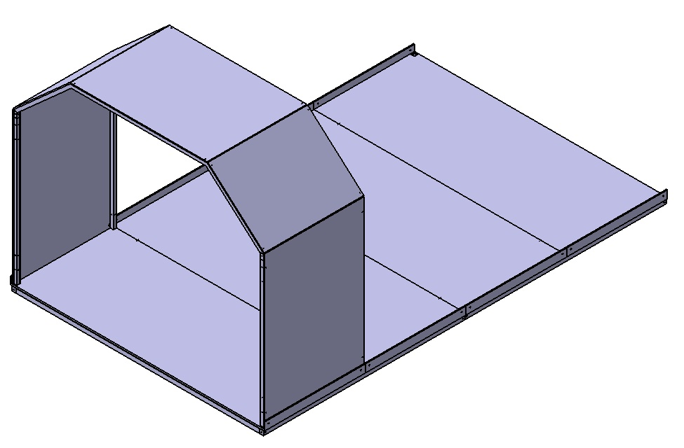

Figure 4: The side wall panels are attached

Repeat this process three more times until all four wall and roof sections have been attached. Now the end wall can be attached to complete the shelter.

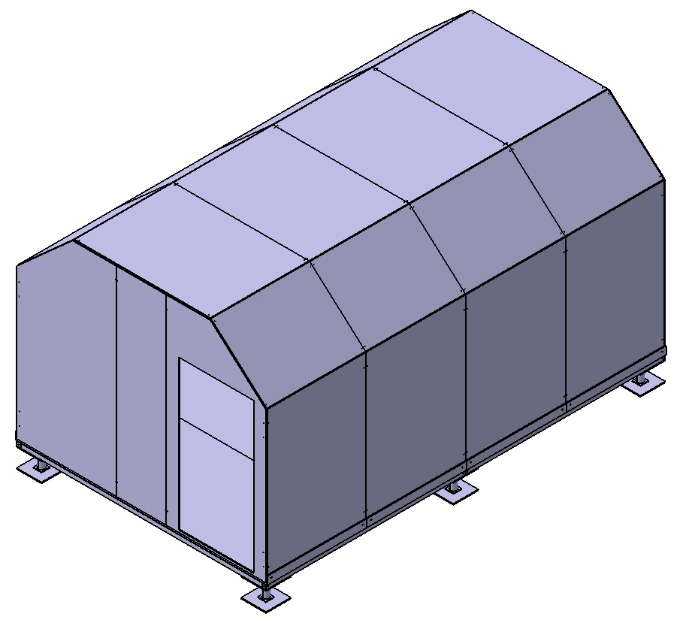

Figure 5: The completed shelter with end walls attached

## Alternate Concepts

The intent of creating a shelter assembled out of smaller light weight components was always at the core of our design and did not change throughout the duration of this project. However the method of attaching the roof underwent several iterations before our team settled on the final rotating wall design. The primary issue we identified was the challenge of users having to lift a roof over their heads and on top of the walls without the aid of heavy machinery.

The first iteration our team came up with was largely identical to the final design of the shelter. The product still featured the same modular wall panels and skeletal frame. However the walls did not rotate into an upright position which meant attaching the roof panels required users to climb onto the roof to secure the panels in place. This design would have featured a small ladder that attached to one end of the shelter. Additionally the height of the shelter was designed to be much lower at only 7’ tall. The intention was that the average person would be able to reach up to 7’ with their arms outstretch meaning they would be able to secure the 6’ high walls without too much exertion. This design was design to be completely modular, with users having the ability to extend the length of the shelter in 4’ increments. Additionally users had the option to swap out and replace the wall and roof panels according to different configuration package. An example would be to replace the DuraPlate roof panels with solar panels to provide additional power for utilities or to replace a wall panel with another wall with larger panels. Another benefit to the modular design would have been the ease of replacing damaged components on a shelter. Like the final shelter design, these roof panels would have featured rubber gaskets to seal off any gaps between panels. Ultimately this shelter design was scrapped as it was deemed impractical and unsafe for untrained users to be lifting large roof panels onto the roof.

The second iteration of the shelter featured the same panel based walls and foundation design but instead had a roll up roof that would unfurl itself similar to a garage door. Instead of having the trapezoidal roof bracket, the shelter would feature curved railings running along the roof. Two 8’ long rolls of roof panels would be mounted onto the side of the shelter and secured onto the ends of the railings. The roof panels would be comprised of a series of shutter-like panels 4” wide and 8’ long connected by links and rolled up into a bundle. The ends of the panels would have small wheels that slipped into a groove in the roof railing. After being secured in place the panels would be unfurled across the railing via a crank mechanism in the bundle. Once fully extended, the ends of the panels could be locked into place in order to prevent the roof from unfurling. Additional weather proofing would have been provided by a large tarp draped over the top of the panels to prevent leakage from between the roof panels. This design was discarded due to the complexity of having to manufacture the rolling roof panels and linkages prior to shipment as well as the added risk of mechanical failure in the unfurling process. Additionally the rolling design provided little weather proof capabilities itself, instead requiring the supplement of the tarp. There were also safety concerns with hair or fingers being caught in both the panel linkages and the railing to which the roof was mounted onto. While the rolling roof design meant users only had to lift the bundle of roof panels up 6 feet and saved users the trouble of having to climb up onto the roof to secure it in place. The bundles themselves would have weighed a significant amount, ultimately invalidating any convenience it provided.

The third iteration was a much larger departure from the previous two roof designs. Rather than having metal shutters and panels, the roof was comprised of a series of insulating foam panels sandwiched between thin sheets of particle board also known as structural insulating panels or SIP’s, all sealed inside a large fire proof tarp.

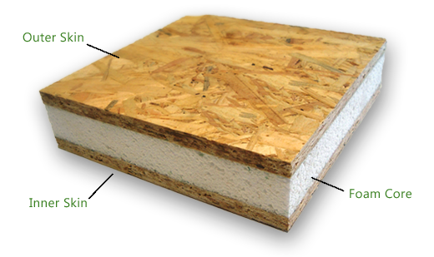

Figure 6: An example of the foam & particle board layers

The foam core was designed to be an inch thick with an R value of 5 to provide insulation while the particle board sheathing was intended to provide a rigid structural support. This combination of foam and particle board would then be sandwiched between two layers of a large fire proof tarp. There would have been a two inch gap between the SIPs. This gap would have a heavy duty stitching in the tarp to provide a flexible gap where the entire SIP/tap assembly would be able to fold in stacks for easy transportation.



Figure 7: Illustration of the tarp and panel setup

The blue in the illustration represents the bottom layer of the tarp, while the yellow rectangles represent one SIP. The dotted red line represents the sticking going in between the gaps of the SIPs. The same logistical issues of how to deploy this roof shape in a practical manner without violating our weight limitations pushed us onto our final design.

## Final Design

The final mobile shelter design ended up being nearly identical to the first alternate concept. While the modular panel based design of the walls and floor remained unchanged through each iteration, the final roof returned to the original panel based design. In order to address the issue of users having to lift the roof panels over their heads a workaround was created to break the walls and roof into four segments. These segments could then be assembled while laying horizontally and then rotated into an upright position. While the user still had to perform a lift motion, the strain on the user is greatly decreased due to the rotation motion provided by the pin joint in the floor. Furthermore, since the walls do not need to be lifted a significant height, the framework of the shelter can be build without the walls attached and allow the roof panels to go up into the air. The reduction in user exertion fulfills one of our key design goals of improving the feasibility of assembly without the need for heavy equipment. This design principle extends to every other part of the shelter design as well. Each bar or panel is designed and dimensioned so that no component exceeds OSHA lifting index of 51lbs per person.

A foundation was incorporated to help level the shelter up to a grade of 5% eliminating the need for site preparation. DuraPlate was utilized in order to leverage the existing material and manufacturing capabilities of Wabash National as well as to lower manufacturing costs. The durability and insulating properties of DuraPlate are also important factors in providing a safe and comfortable environment for users.

The decision to include amenities was due to the focus on providing interim housing from six to twelve months. The intent was to help families rebuild their lives and maintain a semblance of normality while providing a sense of comfort and safety. It was decided that the shelter needed to provide basic utilities for the family to cook, sleep and work in. The inclusion of bathroom fixtures was discussed but was not included in this version due to the added complexities pushing it beyond our scope.

Ultimately the final mobile shelter design manages to meet the three target goals outlined by our team without compromising on features or function. The shelter is cheaper to manufacture, is focused on providing housing for families of four, and is capable of being assembled without the need for heavy equipment.

# Development of Concept- Jian Ruan

The development of concept will break down into 3 separate parts based upon the features of the final design. The design split the structure of the mobile shelter into upper and lower body. The upper body was consisted of walls and roof, and the lower body refers to the foundation. The third part was the design of interior layout and amenities. Each member of the team was responsible for the design of a different part, but the final decision was made with group consensus.

# Foundation

The description of foundation design will follow the spatial relationship of among the essential components. Visual illustration of designs will be provided as complementary. Procedures that are minor or consistent with industrial convention will not be specified. It’s also noticeable that not all the figures are drawn in scale. All dimensions should refer to texts.

### Suspension

The Foundation is supported and suspended by 6 supporting units. Each of them is a premade piece consisted of two 1 square foot steel plate and 1 mechanical jack. The steel plates are welded at each end of the mechanical jack to distribute the load and stabilize the shelter. The dimensions of the mechanical jack are as shown in Figure 2 and Figure 3.

Due to the concern that the product could be used in various conditions and situations, it is essential to have a suspension system that lifts the unit. The major benefits of this feature are twofold. First, it substantially increases the ability of the shelter to adapt to different environments. Since the unit is lifted, water and moisture on the ground will not affect the living space. Keeping the floor dry also makes the unit more comfortable and last longer by decreasing the chance of having mold and bacteria. Second, the incorporation of jacks makes the shelter more adaptive to different ground conditions. In practice, the shelter has a greater chance of being set up on a mild slope or rocky places. Instead of a whole piece of deck sitting on the ground, having adjustable supporting feet reduces contact areas and convenient to make a horizontal floor.

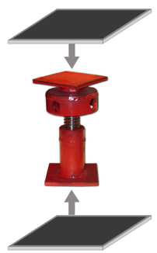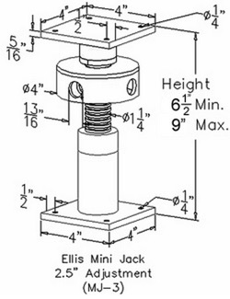

Figure 8: The Ellis Mini Jack MJ-3

The supporting feet will be placed under the 4 corners of the rectangular floor frame and the midpoints of the two longest steel beams. The plate on top of each jack has holes used to attach it with steel beams. The connections are fixed using bolts. Figure 4 illustrates how the supporting feet will attach with the steel beams sat on top of them. The gray area is the top steel plate welded to the jack.

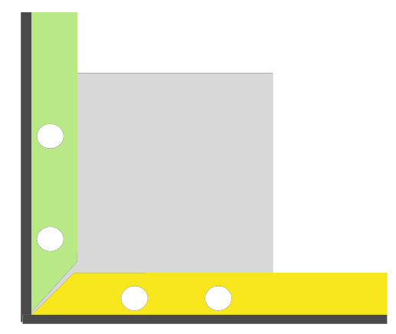

Figure 9: Top view of frame corner

Generally, there are two types of jacks available in the market: hydraulic and mechanical. They cost roughly the same within the range of the design requirements. Initially, a hydraulic jack seemed to be more attractive as it requires less power to use thus friendlier to less physically capable customers. However, the involvement of fluid makes it vulnerable to temperature changes over a variety of climates and seasons. Thus, a mechanical jack better suits the need. The specific model (Ellis Mini Jack MJ-3) is chosen as a result of balancing load capacity and height. Normally, jacks with larger load capacity tend to be shorter in both upstretched height and adjustable height, as well as more expensive. In this particular case, the mobile shelter needs short feet to avoid lifting the unit too high and small load capacity (comparing with industrial use). Eventually, the choice is made by taking cost into consideration.

### Framework

The basic framework is constructed using 4x4x1/4 Equal Leg Angel steel beams. Two 10 ft. beams are placed on the short sides, and four 8 ft. beams on long sides (two on each). The break points between the 8 ft. beams will be connected and strengthened using customized metal binders. The Design of the binder is shown as Figure 5.

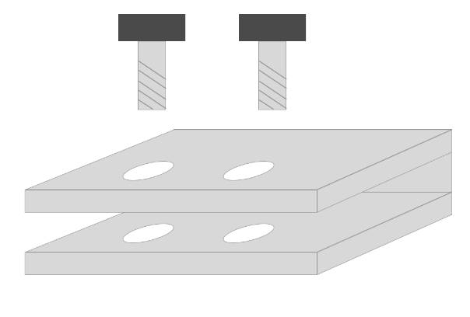

Figure 10: Securing the binder

The choice of 4x4x1/4 Equal Leg Angel Steel is justified by careful calculations. In the feasibility analysis, the 8 feet beam on the long side is the only subject since it bears the most weight. The total weight of the deck and amenity combined is around 1000 pounds. A family of four can weigh 800 pounds at maximum. Addition to it, the walls and roof unit that each spans 4 feet has a weight of 118 pounds. They all add up and distribute the load onto 4 metal bars. And the metal bars concentrate the load on 4 areas on the steel beams. The weight is divided by 2 due to the fact that there are two beams, one on each side, to support. It is also worth to point out that the two bars in the middle take more load than the other two by the ends because most of the activities will happen around the center of the mobile shelter. The model and calculation are shown in Figure 11 and Table 3.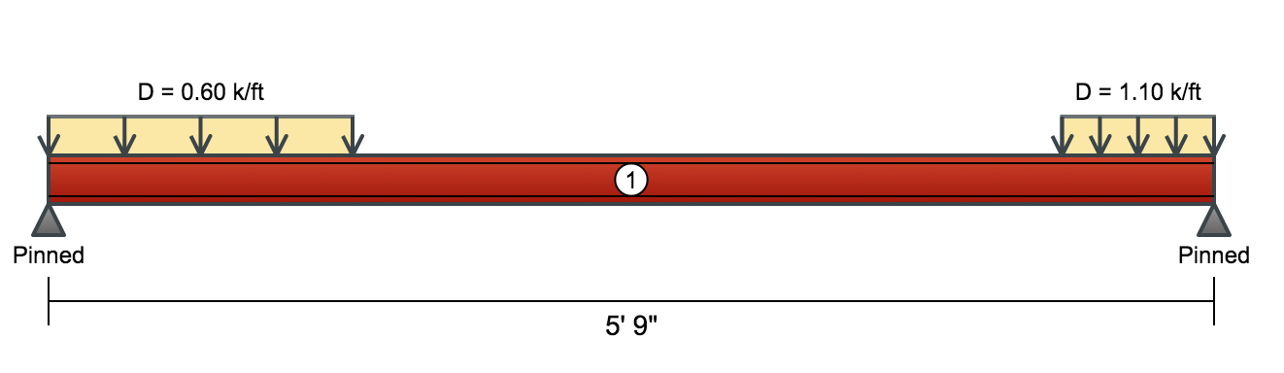

Figure 11: Load distribution on the steel beams

As shown in Table 3, the bending moment is only 0.27 of the allowable number, which is the biggest number among all three essential safety indicators. It suggests that the design has a safety factor of 4 with already exaggerated weight estimations. The length of the beam in Figure 6 only measures 5’9” for the convenience of calculation. There is 2’3” portion of the beam going beyond the right end, which does not bear any load.

Table 3: Load calculations:

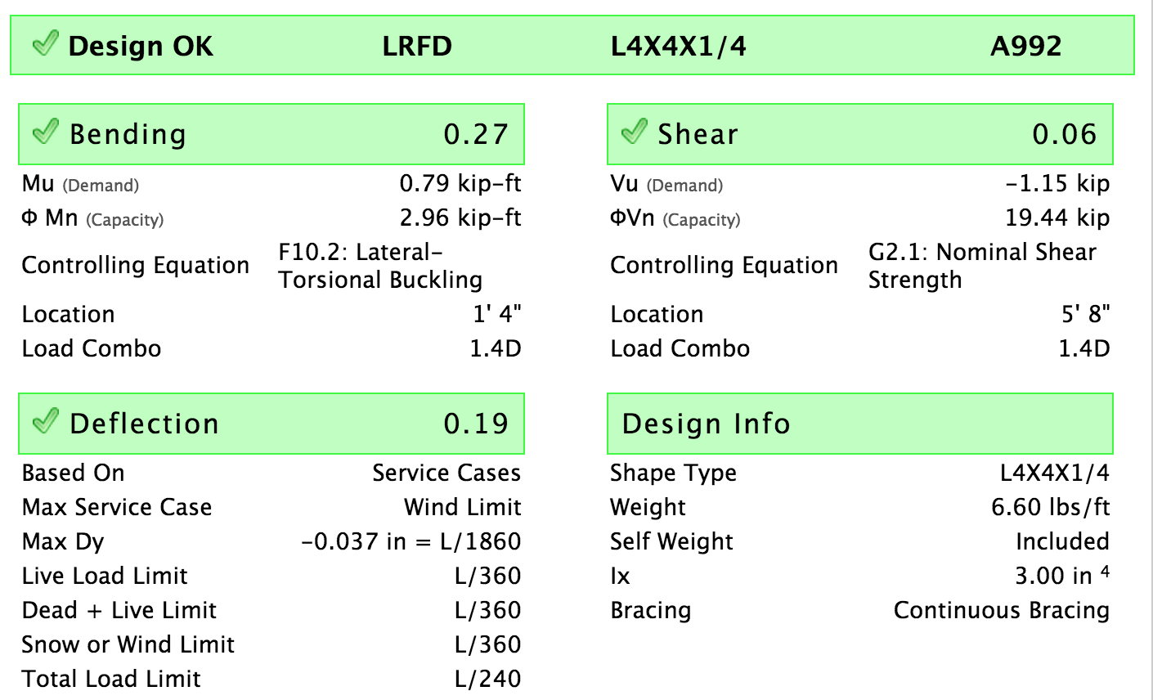

Finally, the beams are connected with each other and bolted at the corners with the supporting units, which forms and 10’ by 16’ rectangular framework.

### Deck

On top of framework is the deck system. There are four (10 ft. x 1.5ft. x 3/16 in.) steel bars held by the horizontal edges of the equal angle steel beams. Each of them weigh just under 100 pounds. The data are referenced from MetalsDepot and should be available from a variety of steel suppliers. They cross beams are equally distributed along the length of the structure. The steel bars provide support for the floor, amenities and the potential load on the living space in the mobile shelter. A conceptual design of an assembled flooring will look like shown in Figure 12.

Supported by the steel bars, 3 pieces of DuraPlates are placed as floor. They all measure the same in the length (58” or 4’10”) but different in width. The panel in the middle has a width of 70” or 5’10” while the other two are 60” or 5’ wide. They add up to 190” or 15’10”. The 2” deduction is due to the thickness of the beams, which 1” on each end. In practice, the number could be deviated from this estimation due to factors like installation errors and manufacturing errors as well as reserving space to allow those errors.

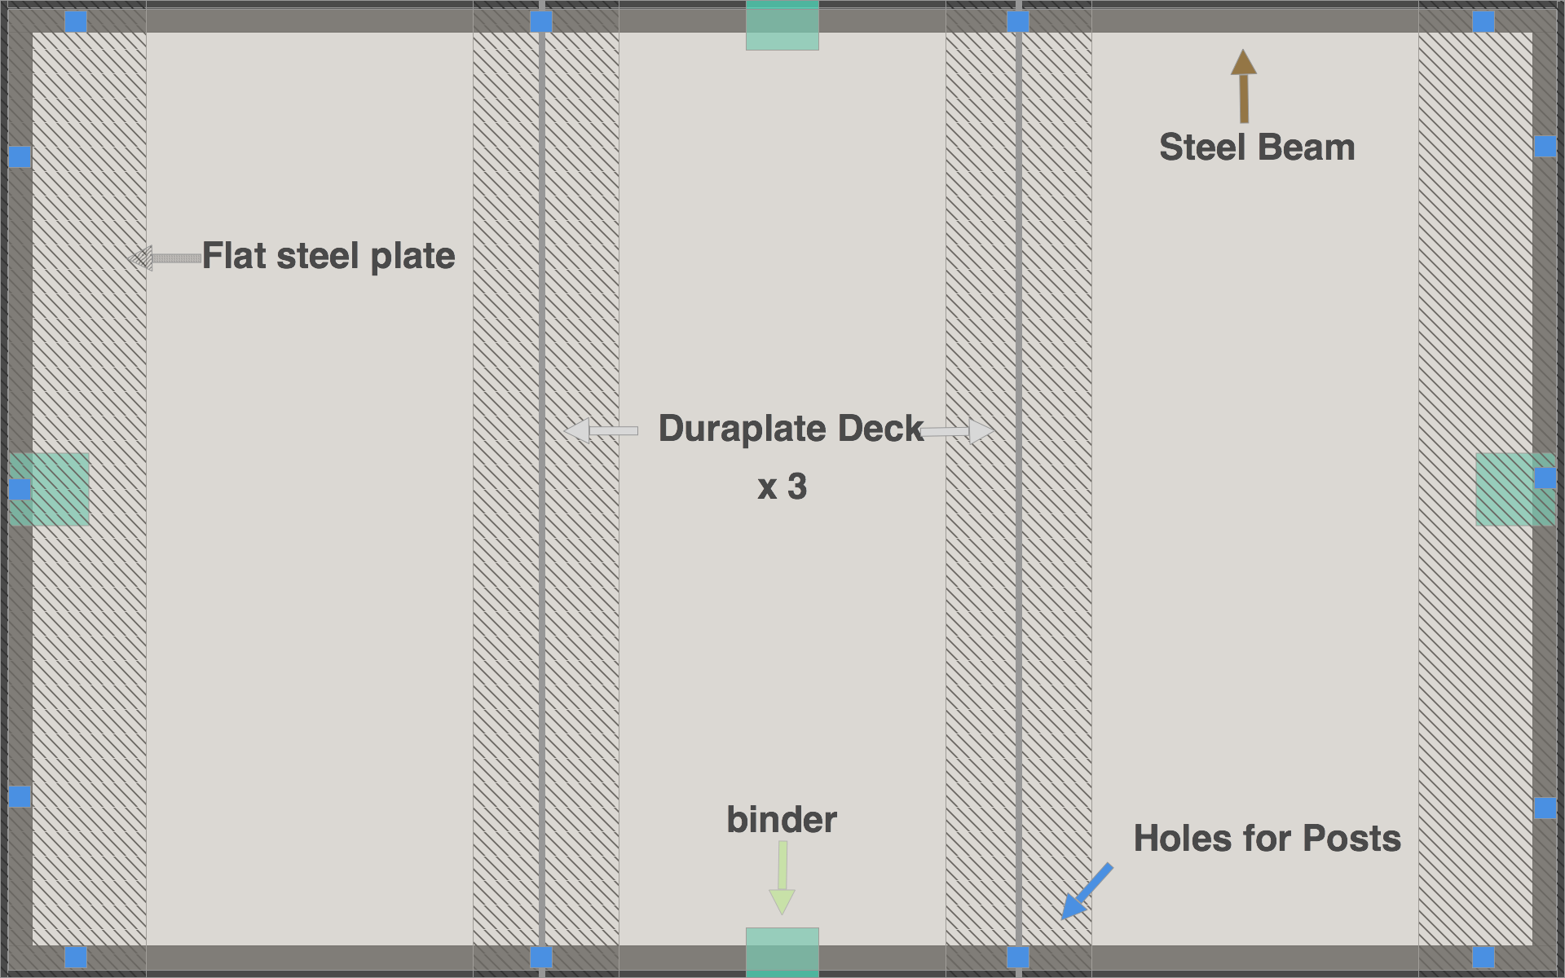

Figure 12: Top view of the foundation connection points

The blue dots on the edges are holes punch through that will later fit the wall posts and stabilize the walls. Figure 13 shows a detail view of the assembly joining each other.

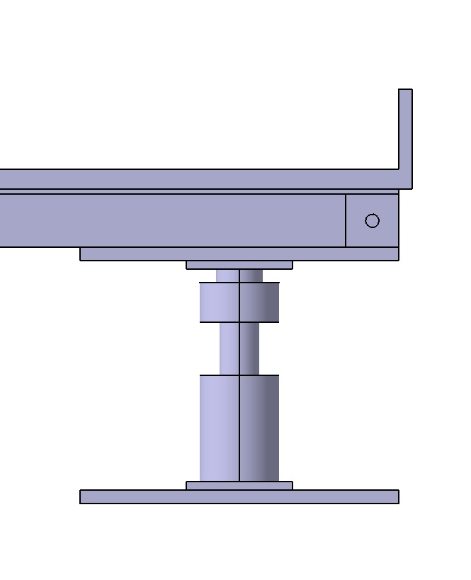

Figure 13: Close up of the frame, support plate and floor panel

Another important point is the design of floor deck, which is DuraPlate in this case. However, the choice is not regular models. Besides providing support to the unit, the floor also serves as a layer of insulation material. It is the only layer between the livable space and outside. If designed poorly, it will significant reduces the overall insulation performance of the entire unit. Given the fact that DuraPlate is customizable, and the plastic core serves as insulation material, the thickest model of DuraPlate would be a good base to start. The relatively thick steel layers can provide extra strength which will compensate potential strength loss due to the increase foam layer. And then the plastic foam core will be increased by 1.5” to provide enough insulation.

## Shelter Enclosure

Different than the walls, the roof affected the easiness of assembly process the most. Potential materials are Polycarbonate, HDPE (High-density polyethylene), Vacuum Insulated Panel and Tarp. After research and investigation, a comparison table is formed as below. Due to obvious advantages that DuraPlate has, it was chosen for the panel material.

Table 4: Material pros & cons

|  |  |  |
| --- | --- | --- |
|  | Pros | Cons |
| Polycarbonate | Insulated, lighter weight | Expensive, hard to use |
| HDPE | Cheap and light | No insulation |
| Vacuum Insulated Panel | Good insulation | Expensive, fragile and dense |
| Tarp | flexible | Hard to execute, heavy |
| DuraPlate | Good insulation, strong | Somewhat expensive |

The design was made to balance the functionalities and easiness assembly. The trapezoid shape was kept for the purpose of increasing livable space. Another competing idea with regard to the shape was simply increasing the wall height. However, a wall panel taller than 6’ means going beyond the limit of the “average person” assumption. Many people may find it difficult to move the panel and put the roof on. With stark contrast, trapezoid did not have this disadvantage. It limits the ceiling height on the near edge areas, but livable space in the middle, which is more important, is substantially larger. Considering the DuraPlate manufacturing specifications, the angle between the inclined panel and the horizontal axis is determined to be 41.81 degree. It led the width of angled panel to be 3 feet with a rise of 2 feet over a distance of roughly 2.24 feet as shown in Figure 14.

The core of the roof design is combining the roof and the walls, and modularizing them as 4 smaller units. The concept is to create an “Arbor” style frame for all the panels to hang off of. This design treats walls and roof equally—all as part of the smaller “arbor unit”. By cutting the roof into smaller piece (same width as wall panel), using DuraPlate for the roof is made possible. Specifically, each “arbor unit” is the consisted of two 4’ by 6’ (4’ in width and 6’ in height) wall panels, two 4’ by 3’ angled panels and one 4’ by 5.5’ panel with steel beams attached to the unit.

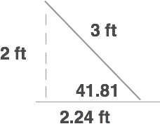

Figure 14: Roof angles

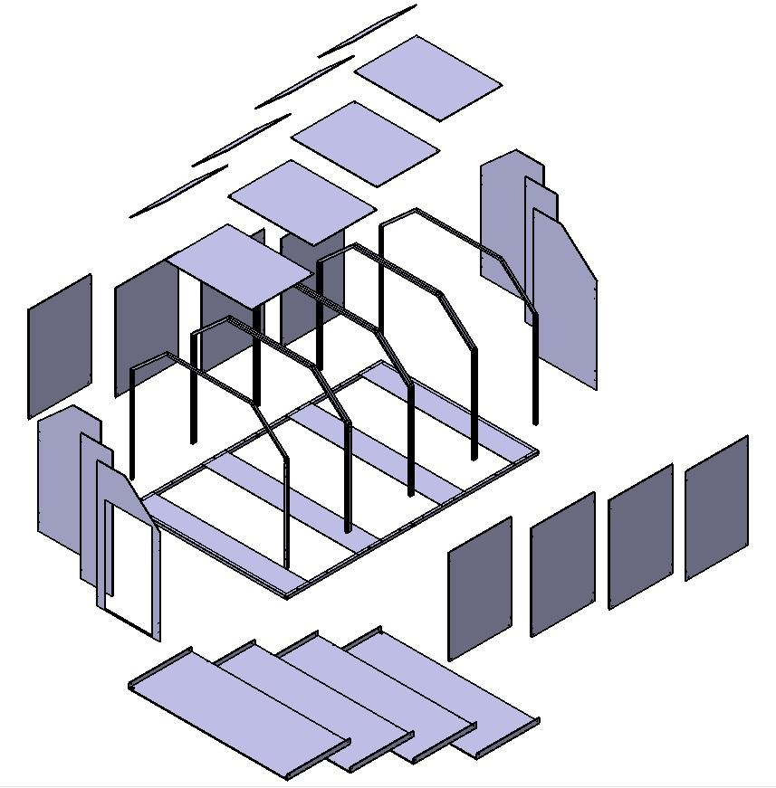

Figure 15: Exploded view of all shelter components

Similar to the foundation, the DuraPlate will also be customized to increase the insulation plastic foam layer by 1 inch. It provides on overall insulation R value of 7, which is better than any other alternatives that listed in Table 2. With respect to the seal, a layer of rubber gasket will wrap around the panel edges, and latches will pull different panels together (it will be refer as “rubber-latch” system) as shown in Figure 13.

With regard to the frame, steel framing is selected for its cost to weight performance. The basic bending moment analysis found it to be strong enough. Another alternative is a different execution of the steel frame. The reason we didn’t use the high wall steel was it did not simply the assembly process. This reduces a great deal of the needed strength off the steel as it only needs to keep the panels upright, but to support the weight of many panels in air. We were concerned about the ability of Duraplate to support itself once deployed, but after performing a more detailed stress analysis, we were convinced otherwise.

## Assembly Process

Once the foundation is completed the floor panels can be installed. There are four panels that comprise the floor of the shelter. The panels measure 4’ wide by 10’ long and are built out of a custom sheet of DuraPlate measuring 0.75” thick. The extra thickness is due to extra foam insulation on the inside of the DuraPlate, designed to reduce heat loss through the floor of the shelter. These floor panels are then attached one at a time, end to end, on top of the foundation. The ends of the floor panels have a rubber gaskets lining sealing off any leaks and providing additional weather proofing once everything has been secured. If properly secured the lip on the outer ends of the floor panels should be aligned.

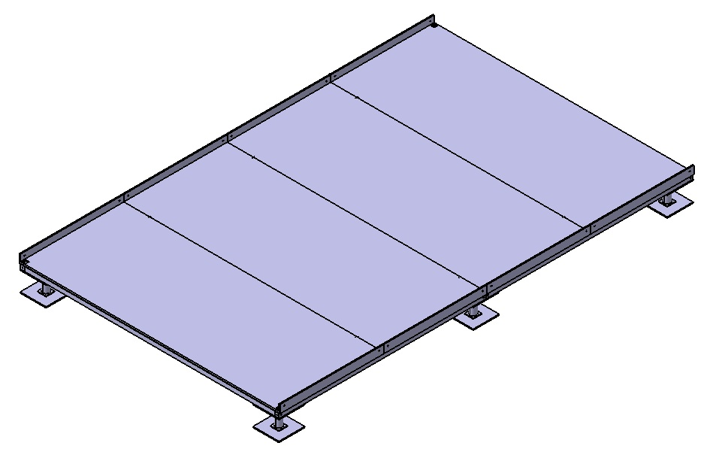

Figure 16: Foundation with floor panels attached

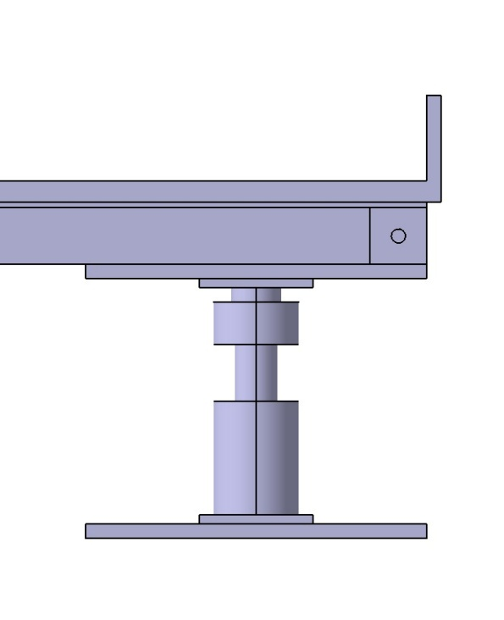

Figure 17: Close up of the lip of the floor panel

The next step of the assembly process is to assemble the structural wall posts that serve as the skeletal framework of the roof and walls. The shelter has sixteen 6’ wall posts, eight of which have a red marking label on them. At the bottom of these posts is a labeled hole which aligns with the holes on the end of the floor panel lip. With one person holding the post securely upright a second person will slide a pin through the hole on the lip and through the wall post. Repeat this process four more times. If done correctly there should be four pairs of wall posts, with each pair having two posts opposite each other. Once each post in secured using the pin, it may be rotated downwards until it is resting on the floor as shown.

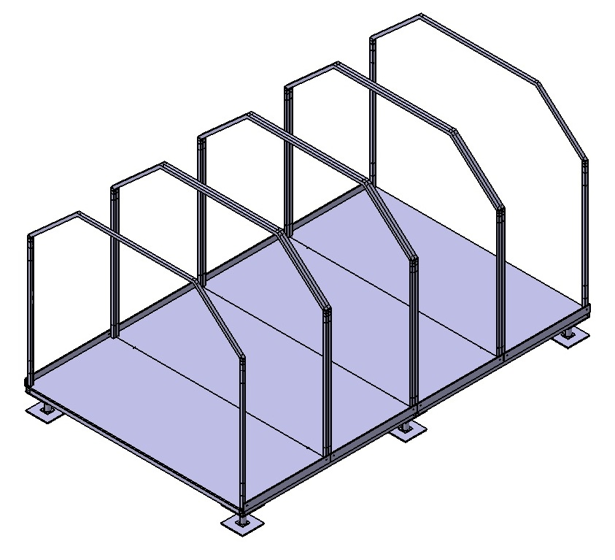

Figure 18: The skeletal frame of the shelter

Now it is time to connect the opposing pairs of wall posts with the roof brackets. The wall posts are hollow, forming a groove for the ends of the roof bracket to slide into. Simply slide the ends of the bracket into the ends of the wall posts as shown.

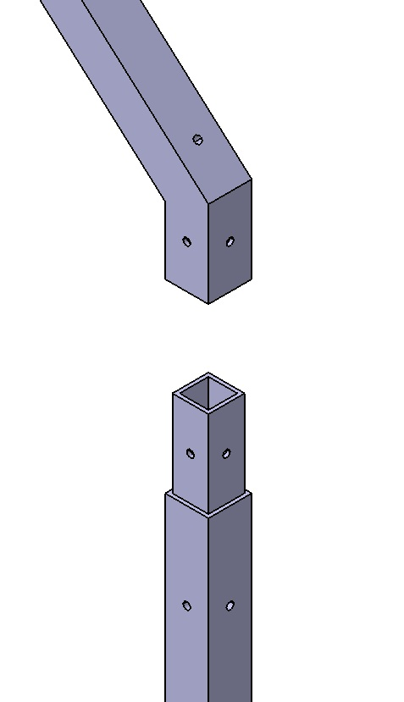

Figure 19: Connecting the roof brackets to the wall posts

Once the bracket has been mated with the wall posts, secure the connection using the provided screws. If done properly the resulting assembly should look like this.

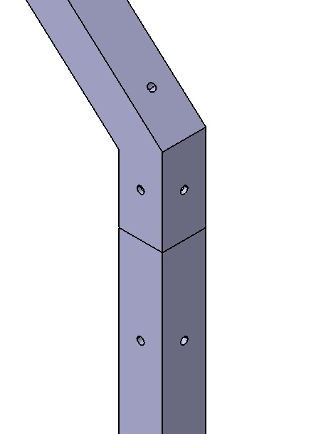

Figure 20: Properly mated bracket & post

It is now time to begin attaching the roof panels to the bracket. With the connect brackets and posts rotated downwards, first take the larger panel and affix it to the center portion of the roof bracket as shown. Attach the two smaller roof panels to the slanted portions of the bracket. If done properly the result should look like this. Like the floor panels the roof panels feature rubber gaskets on the ends as a seal to provide weather proofing and insulation.

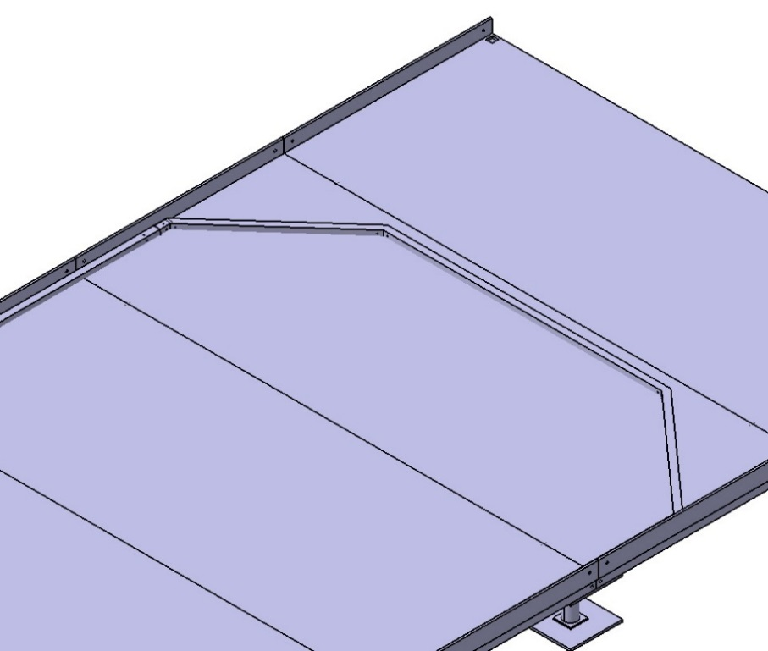

Figure 21: Mated bracket and wall post rotated horizontally

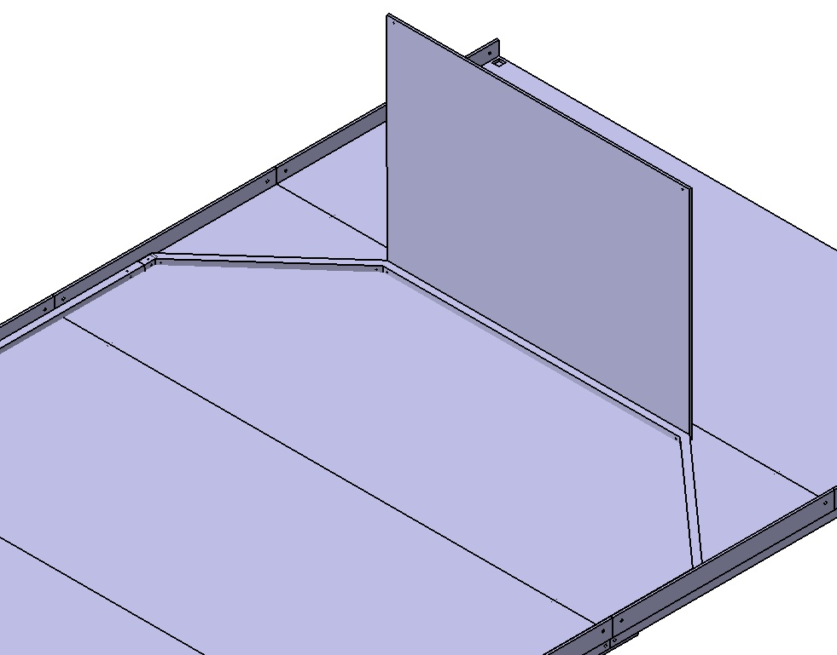

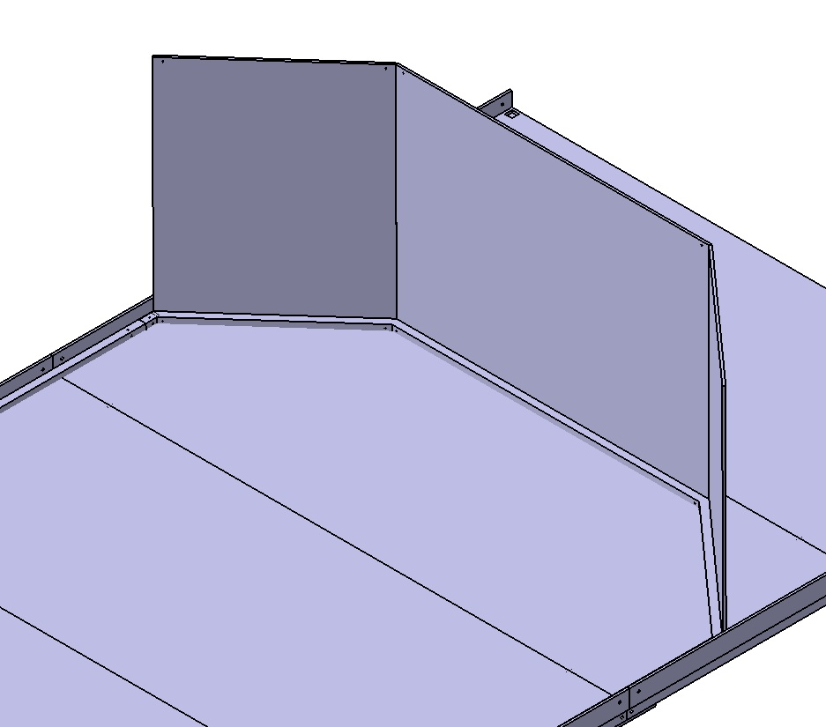

Figure 22: Add each roof panel one at a time

Now with the wall post and brackets lying down horizontally, attach and secure another roof bracket on the ends of the roof panels. Then affix a wall post to either end of the newly attached roof bracket.

/****

Figure 23: Attach and secure the second set of bracket & posts

Now, slowly rotate the wall post and roof upright to a vertical position. Secure the bottom of the wall posts to the floor panels with the provided screws and remove the pin connecting the post to the floor lip.

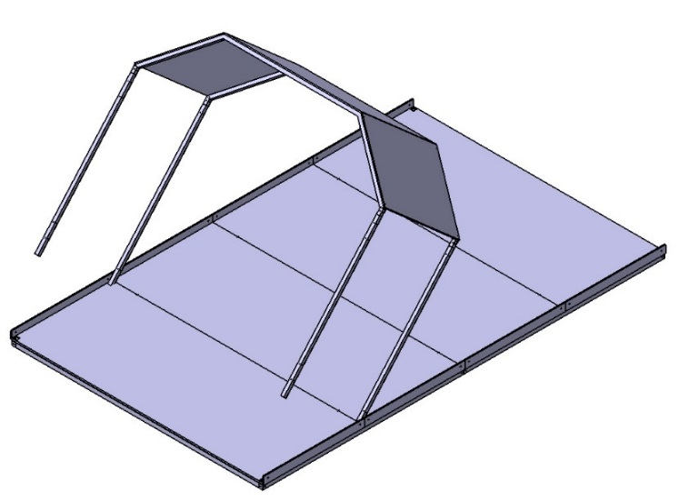

Figure 24: Slowly rotate into an upright position

Now that the wall segment is properly oriented it is time to attach the wall panels. Each wall panel measures 4’ wide and 6’ tall and is made from 13mm spec DuraPlate panels. Align the holes on the ends of the wall panel with the holes on the wall posts. Gently slide the wall panel in between the wall posts and the floor panel lip as shown. The wall panels feature rubber gaskets to provide the same sealant and weather proofing as the floor and roof panels.



Figure 25: Completed wall & roof section

Ensure the holes on the wall panel and wall posts are properly aligned and then secure the wall panel to the post using the provided screws. If performed properly the shelter should look as shown.

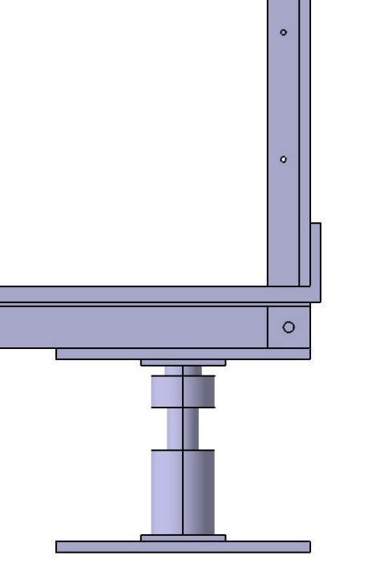

Figure 26: Wall panel slides in between wall post & floor lip

Repeat this process three more times with the other wall sections. If done properly the shelter should look like the following image.



Figure 27: Repeat the process 3 more times to fully assemble the shelter

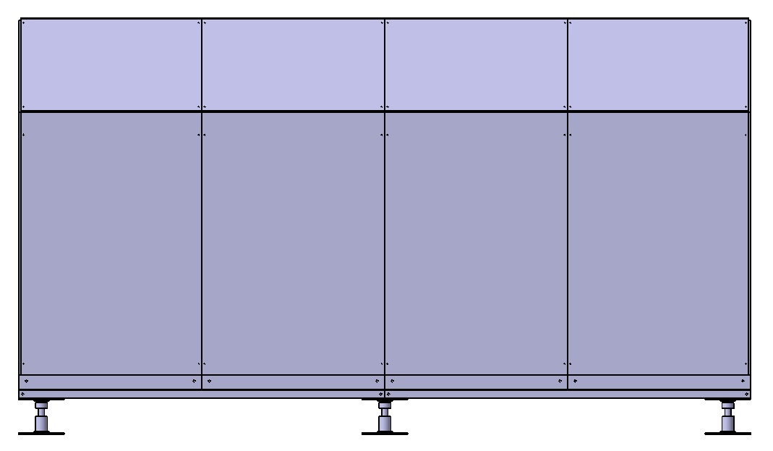

Figure 28: Side view of the completed shelter

## Interior

Due to our team’s scope focus on the safety and protection from the outside elements as one of the main goals of our shelter, the interior became a smaller necessity than the shelter’s structure.  The interior was given a cost restriction of being able to use what is left in the budget after the shelter’s structure is made that would still allow it to be considered competitive within the market.  Without the knowledge of the savings that could gained from using Wabash National’s in house manufacturing, ability for buying in bulk, and savings that might be encountered from previously formed business contacts, it is difficult to say what items could be implemented in the design of the interior without going over the budget.  Knowing this, many possibilities were formed but nothing could become concrete without further knowledge.  In light of this, the priority of the amenities were analyzed, so that the more necessary and important items could first be implemented, and anything after them could be added for comfort if the budget allows.

Table 5: Utility dimensions

|  |  |  |
| --- | --- | --- |
| **Amenity** | **Dimensions** | **Priority** |
| Safety: Deadbolts, Smoke detector, Door Alarm | N/A | Top |
| 4 Beds with padding, blankets, and pillows | 6’ long x 3’ width each  Height difference between bunk beds ~ 2’ 11” | Top |
| HVAC | N/A | Top |
| Cooking Ability: 2 Burner Stovetop | ~ 1’w  x 1.67’L | Medium |
| LED Lights and power source | 4 LED lights | Medium |
| Storage: Armoires/lockers | 16” x 36” x 72” | Medium |
| Place to eat: Table and chairs | 2’w x 6.5’L = Table  1’w x 1.4’ per Chair | Medium |
| Storage for cleaning and cooking supplies: kitchenette | 7.14’w x 1.82’L =Counter  Has 2’ height between cabinet bottom and counter top | Medium |
| Sink system | 1’w  x 1’L | Med- Low |
| Privacy Curtain | 2 curtains at 6 feet height and a 4.75’ width | Low |
| Small Personal Safe | Small enough to fit in Armoire/locker | Low |
| Desk separate from Table | Too large of a range of possibilities to have a dimension | Low |

First priorities are the safety implements like a deadbolt for the door, a door alarm, and a smoke detector.  A safety grab bar is cheap and could be easily installed on the exterior next to the door to facilitate the step up into the shelter due to the height change from the ground to the shelter floor.   The next would be four beds for each person to sleep on.  One of the most important aspects of survival is being able to maintain a body temperature within a range of 97.5-98.8 ⁰F.  Ways to regulate it would be having a place to sleep that gives warmth rather than take it away. Body heat tends to transfer to floors.  Another way to regulate the body would be to have an HVAC installed to regulate the room temperature.  Windows can also get implemented in such a way that produces cross breezes for natural cooling on nicer days.  Thermal shutters (if money allows) help to increase the R-value by ≈5 to the windows when shut.  They should only be looked at for implementation after other necessities are looked at. In order to provide users the ability to cook their own meals, two small removable burners are included.

Several floor plans were drawn up using the priority list as a basis and can be seen in Table 4.  The floor plans were created using a space with the assumption that all the walls were 3 inches thick, leaving a floor space of 15.5 feet by 9.5 feet and wall space up to 6 feet in height.

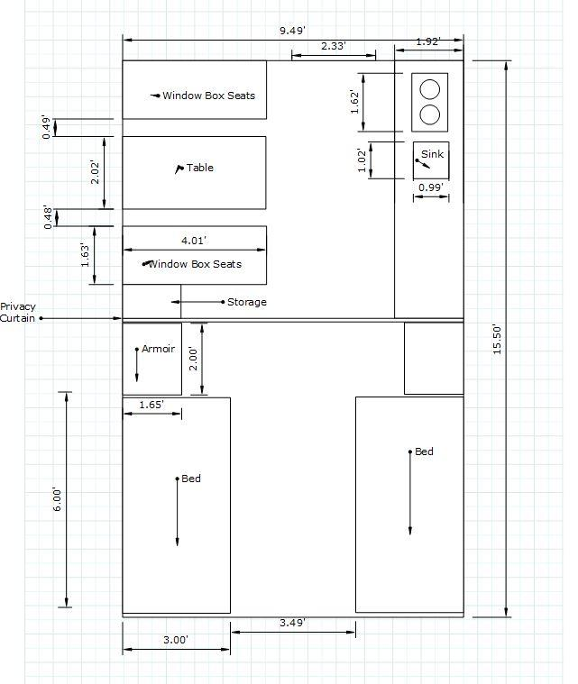

Figure 29: Floor plan 1

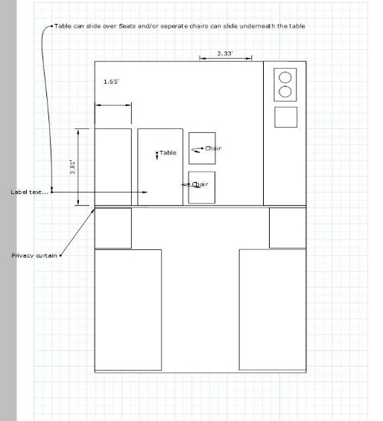

Figure 30: Floor plan 2

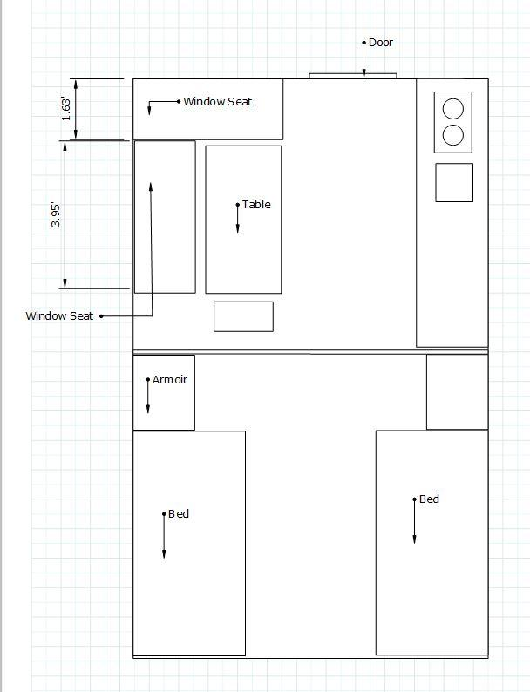

Figure 31: Floor plan 3

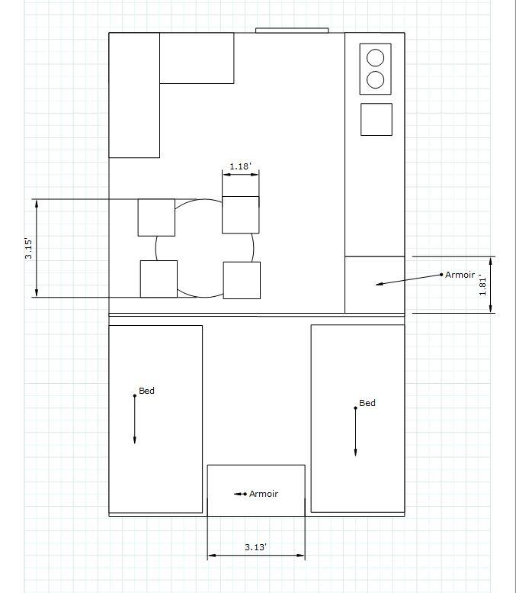

Figure 32: Floor Plan 4

After assessing the different plans a single plan was decided on as the best balance for a more basic shelter that could be added to if costs and room allow.  This floor plan can be seen in Figure 23.  The dimensions required for the amenities chosen as if looking down on top of the shelter are marked in the figure.

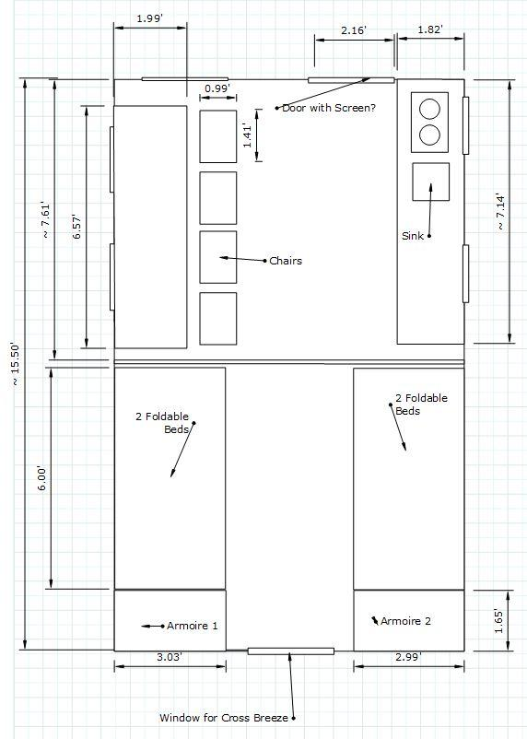

Figure 33: The final floorplan layout

Turning this shelter into a livable area for a family over a 12-month period was quite the challenge, and providing enough storage space in a small living environment is a significant part of that challenge. Using the ideas shown in Figure 24, we propose to create an armoire that pulls out allow for a deeper storage unit and increase the usage of the floor space. Two people would share an armoire to store their belongings inside the shelter. Ensuring that basic levels of privacy can be maintained in these cramped quarters, we also spaced a privacy curtain could also be implemented to separate the kitchen area from the bedroom area.  This is an object that would be cheap and easy to implement without taking up much room in the shelter nor when being shipped.

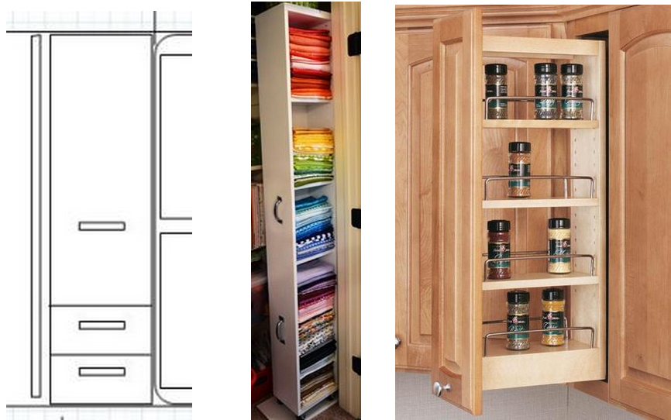

Figure 34: Storage options

The table would be made with hinges to allow for it to bend down when not in use in order to create more space in the shelter.  It could be made out of bamboo to decrease cost and weight, while keeping quality.

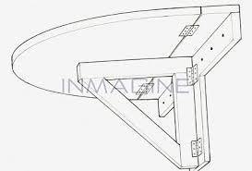

Figure 35: Fold down table

## Cost Estimation

In general, the total cost splits into six different areas: $285 in security, $605 in Furniture, $1081 in walls, $1010 in Floor, $576 in roof and $966 in utility. The percentages are clearer in Chart 3. They add up to a total of $5087, which is 20% less expensive compared with the Wabash National’s current model.

Table 6: Cost breakdown

|  |  |  |  |
| --- | --- | --- | --- |
|  | **Panels** | **Beams** | **Other** |
| **Walls** | $670.56 | $409.92 | N/A |
| **Floor** | $352.00 | $370.28 | $288.00 (jacks) |
| **Roof** | $252.67 | $322.78 | N/A |
| **Empty Shelter** | $1275.23 | $1102.98 | $288 |

Since the entire structure basically is composed with panels and beams. The cost estimation of structural part can be represented roughly as the sum of the cost of panels and the cost of beam.

Table 7: Amenities & utility cost breakdown

|  |  |  |  |  |  |
| --- | --- | --- | --- | --- | --- |
| **Utilities:** | **Sink** | **HVAC** | **Lights** | **Power** | **Stovetop** |
|  | $134 | $250 | $48 | $88 | $85 |
| **Security:** | **Alarms** | **Door** | **Deadbolt** | **Safe** |  |
|  | $17 | $193 | $15 | $60 |  |
| **Furniture** | **Table Set** | **2 Armories** | **4 Beds** | **Kitchenette** | **Curtain** |
|  | $113 | $269 | $436 | $103 | $45 |

The estimation for total cost for shelter structure is $3231, and that of amenities is $1856. They add up to $5087. More detailed cost analysis can be found in Appendices.

## Future Design Improvement

So far, the design the shelter defines a compact living area, but it does not define the plumbing system and the shipping process. They are parts of a functional design. Due to the limit of time, they are not included in the final report.

### Plumbing

There are two issues involved in plumbing system. First is the water input and output for the kitchen set, and the second is the design of bathroom. With respect to the design of rest room. There are many aspects to be considered. The dimensions of the mobile shelter are limited by local and international standards. Simply enlarging the volume of the container to fit in a bathroom was not an option. The requirements for building material are different. In the previous sections, the strength of panels, its resistance to flame and insulation performance are the major concerns. However, they doesn’t directly apply to the design of bathroom. Resistance to high moisture, water proof and resistance to mold and bacteria are prioritized. Similarly in both cases, the input and output pose another problem that needs to be carefully designed. They have to be meet the requirements of how they should be connected to municipal water system. Last, the disposal of waste is another challenge to be taken care of to meet users’ needs. The restrictions of building codes is a significant challenge that still must be met for a self-assembled shelter.

### Electrical Utilities

To be a functional living space, electrical implementation is essential. However, it’s not fully taken into consideration for the design. Power sources, electrical grid and cost estimation of them are absent, which should be addressed.

Power sources can be off-grid (such as generator or battery) or on-grid. In practice, having access to both sources is required given the fact that areas experienced disaster are highly likely lacking stable power supply while it’s also not feasible to solely rely on independent power sources.

In terms of installation, the wire system could be the most complicated problem to the users without proper design of circuit map. We did address the power distribution for this shelter as none of the designers have experience working with and designing mains voltage power systems. We did not feel comfortable working with this potentially harmful power source without more experience. We did account for the cost of electrical implementation for our system and we have several guidelines that we believe should be met. The shelter should be able to support a two burner stove, a small heater, a small refrigerator, and one other general use appliance simultaneously. This will allow for he most normal life as accustomed to people from the United States.

### Shipping

To be competitive in the market of mobile shelters, fast and efficient shipping solution plays an important role. It directly determinmes the response time that Wabash National has to unpredictable disasters. The shipping method is not well articulated in the current design. Although, each unit is highly modularized and all the parts are weighted. An effective shipping solution is not given. Wabash National is a leader in the shipping industry and already possess a vast distribution network of their trailer dealer systems. We believe that with their experience and resources, Wabash National will be able to create a far superior system than we would be able to construct ourselves.

## Citations

* Shelter: The RDM - Visible-Good.com. (n.d.). Retrieved March 13, 2015, from <http://visible-good.com/shelters/>
* FORTS® Offers Luxurious Portable Buildings & Spacious Fold-Out Modular Buildings for Rent. (n.d.). Retrieved March 13, 2015, from <http://fortsrental.com/>
* DURAPLATE Foldable Mobile Shelters. (n.d.). Retrieved March 13, 2015, from http://wabashcomposites.com/docs/composites-documents-and-files/duraplate_foldable_mobile_shelter_final.pdf?sfvrsn=2
* National Disaster Housing Strategy. (2009). Washington, DC: FEMA.
* Anderson, L. (n.d.). Housing Options for Hurricane Sandy Survivors [FEMA]. Retrieved from <https://www.fema.gov/blog/2012-11-10/housing-options-hurricane-sandy-survivors>
* FEMA. (2009). *National Disaster Housing Strategy*. Retrieved from <http://www.fema.gov/pdf/emergency/disasterhousing/NDHS-core.pdf>
* *Fires in the U.S.* (2014). National Fire Protection Association. Retrieved from <http://www.nfpa.org/research/reports-and-statistics/fires-by-property-type/residential>
* Gus. (n.d.). *Presentation to IDE485 Class*.
* Kelly, J. (n.d.). *Unless Modified, FEMA’s Temporary Housing Plans Will Increase Costs by an Estimated $76 million annually* (No. OIG-13-102). Department of Homeland Security: Office of Inspector General.
* Retrieved from http://cnsnews.com/sites/default/files/documents/FEMA%20IG%20report.pdf
* OSHA. (n.d.). Materials Handling: Heavy Lifting [OSHA]. Retrieved from https://www.osha.gov/SLTC/etools/electricalcontractors/materials/heavy.html
* Perry, W. (2013, April 28). After Hurricane Sandy, Homeless still number in Thousands in New York, New Jersey. *Huffington Post*. Retrieved from http://www.huffingtonpost.com/2013/04/28/hurricane-sandy-homeless-homelessness_n_3174444.html
* Siniavskaia, N. (2013). *How Long Does it Take to Build a House*. NAHBA Eye on Housing. Retrieved from http://eyeonhousing.org/2013/10/how-long-does-it-take-to-build-a-house/
* Wabash National. Wabash Composites. *Duraplate Foldable Mobile Shelter*. *Wabash Composites*. Wabash National, 2012. Web.
* "Humanitarian Charter and Minimum Standards in Humanitarian Response." *The Sphere Project*. The Sphere Project, n.d. Web. 10 Mar. 2015.